Objective

Power BI dashboard and reports come with a usage metric, which you can see how users used this content. As a BI team, we want to see across all workspaces in the tenant, how the consumption of reports and dashboards; Who created reports, who are users of them, in which workspace these are located etc.

Power BI Activity logs only contain Up to 30 days of history which limits our insight capabilities to analyze usage or trend reports.

Solution :
To overcome this limitation we would like to extract data from Power BI API and load it to EDW so that we can build the history of data.

Solution overview
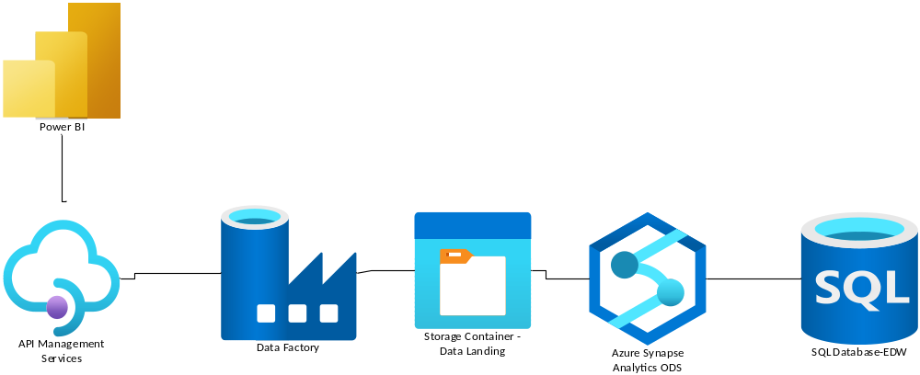

Power BI Activity Log - Power BI

